company logo

# Accessibility Guide for The Example Attraction

[inclusivetourism@visitscoltand.com](mailto:inclusivetourism@visitscoltand.com), [0141 472 2218,](tel:0141%20472%202218) <www.visitscotland.org>

**Contact for accessibility enquiries: Joe Bloggs**

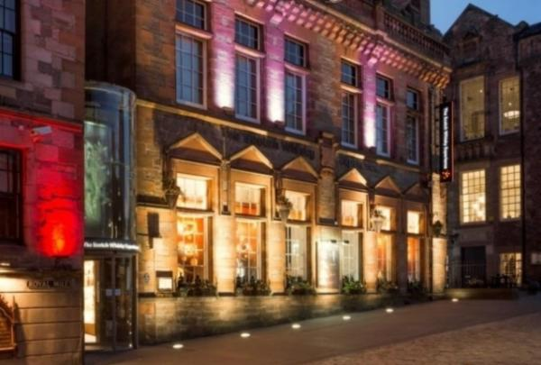

### Welcome

Our visitor attraction is on Edinburgh's principal shopping area, Princes Street, where we’ve been inspiring visitors to Edinburgh about the joys of Scotch Whisky for over 25 years.

Whether you take a tour, visit our shop or restaurant, or enjoy an event or tasting here, we guarantee a sensational experience.

We are fully accessible for wheelchair users and can cater for anyone with other specific access requirements.

Please get in touch if you require any further information about specific access or need advice on planning your visit.

## At a Glance

### Level Access

* There is level access from the main entrance to:
  + Dining Table
  + The tour - barrel car ride
  + The Sense of Scotland Room
  + The Blender's Sample Room
  + The Diageo Claive Vidiz Scotch Whisky Collection
  + The McIntyare Whisky Gallery and Bar
  + Ticketing area
  + Unisex Accessible Toliet
  + The Shop

### Hearing

* We have a hearing loop in all public areas throughout our attraction.
* All staff have disability awareness training. Some staff have BSL training

### Visual

* Glass doors and full-height windows have contrast markings.
* The walls and the doors have high colour contrast.
* Some parts of the venue have low lighting.
* The menu is in large print.
* We have display information in audio and BSL.
* We have information in audio, BSL, large print and other.

### General

* We have a complimentary ticket policy for personal assistants.
* All staff have disability awareness training.

## Getting here

A Street Somewhere  
Edinburgh  
Midlothian  
EH6 6JH

#### Travel by public transport

* You can get to The Example Attraction by bus, train and tram.
* The nearest bus stop is on Princes Street The bus stop is 0.3 miles / 0.5 km from The Example Attraction .
* The nearest train station is Waverley Station . The train station is 0.6 miles / 1.0 km from The Example Attraction .
* The nearest tram station is St Andrews Square . The tram station is 0.5 miles / 0.8 km from The Example Attraction .

#### Travel by taxi

* You can get a taxi with City Cabs by calling 0131 228 1211. The taxi company has a wheelchair accessible vehicle.
* Accessible taxis should be booked in advance. To access the attraction please ask to be dropped off at our front entrance. From April to October there is restricted vehicular access to Princes Street, however drop-offs and pick-ups are allowed for disabled visitors.

#### Parking

* There is a drop-off point at the main entrance. The drop-off point has a dropped kerb.
* There is no parking at the attraction, however there is an NCP car park on Cowgate Street with 750 spaces, 6 of which are blue badge holder bays.  The NCP car park is 1 miles from the attraction.  There are intercoms located at the entrance, exit and pay machines if assistance is required.  There is on-road parking around the  venue as well, however this is charged by the hour.  
  The surface from the on-road parking area and car park to the entrance of the attraction is a mix of both paved and cobblestones.    
  The lighting in the NCP car park is new LED lighting.  Street lights light the route to the attraction.

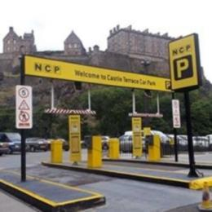  
NCP Car Park

## Arrival

#### Path to main entrance

* From the street to the main entrance, there is level access.
* The path is 990mm wide, or more.
* The path is sloped.

#### Main entrance

* The main entrance has level access.
* The door is 840mm wide.
* The main door is sliding and automatic.
* The walkway to the reception desk has a small incline. There is a projected image on the flooring area as you enter. The floor is made of stone.

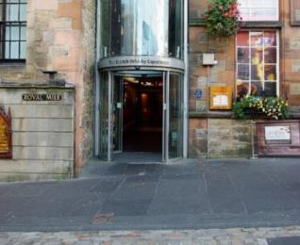  
View of our main entrance from the street

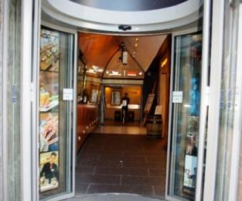  
Our main entrance

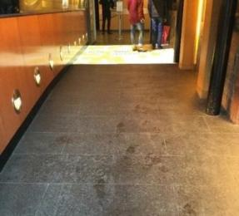  
Entrance lobby

## Getting around inside

#### Visual Impairment - General Information

* We have contrast markings on all glass doors, contrast markings on all full-height windows and high colour contrast between walls and doorframes.
* Some parts of the venue have low lighting.

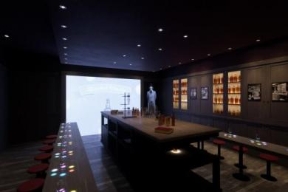  
The Blender Sample Room with low lighting

#### Lift

* We have 1 lift.
* You can get a lift to some floors.

#### Lift to most floors

* The lift door is 800mm wide.
* The lift is 900mm wide. The lift is 1450mm deep.
* The lift says the floor number at each floor.
* The lift buttons have raised numbers or letters.
* The lift shows the floor number, at each floor.
* The lift provides access to most floors of the attraction. The lift does not access the mezzanine level of the shop. The lift serves the restaurant, reception, tour, bars and event and office spaces. There is a mirror located on the left-hand side of the lift. The lighting in the lift is LED spotlights and there is no music played in the lift. The flooring in the lift is PVC non-slip material.

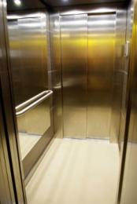  
interior of the lift

#### Ticket/ information desk

#### Ticketing area

* From the main entrance to the desk, there is level access. The route is 900mm wide, or more.
* The desk has a low section.
* There is bench seating available in this area. The area is well and evenly lit by ceiliing spot lights. There is a complimentary ticket policy for carers; this excludes any whisky consumption. There is a hearing loop at till points. If required, assistance can be given through the use of hard of hearing scripts, magnifying glasses or pens and pads or paper.  
  There is also a touch-screen prviding information in 20 launguages at reception.

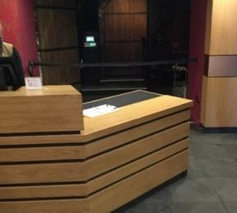  
ticket desk with low counter desk area

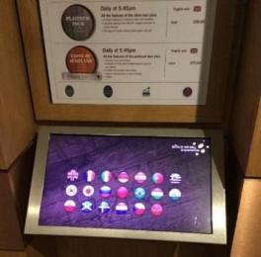  
touch-screen providing information in 20 languages

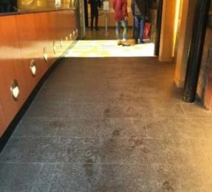  
walkway to ticket desk

#### Things to See and Do

* We have a complimentary ticket policy for personal assistants.
* We have display information in: audio and BSL.

#### The tour - barrel car ride

* From the main entrance to this area, there is level access. There is a lift.
* From the lift to this area, the route is 850mm wide, or more. Some display information is low, for wheelchair users. There are seats.
* There is a hearing loop.
* Videos have subtitles.
* Some displays have flashing lights.
* Our barrel ride is available in 15 languages. The barrel has speakers within it and an induction loop. Scripts can be provided. The barrel car ride does have an elemennt of flashing lights, however this is only for the first ten minutes of the tour and customers can opt out of this option if they want to. There is a ramp for wheelchair users to use to enter the accessible barrel, and staff are on hand to assist with this. To get into the barrel the wheelchair user must enter backwards, to exit you must face forward. There is also a seat within the accessible barrel for an accompanying customer. Customers exit the barrel ride in a dimly lit area. After the barrel ride, customers are given a phone style handset for the audio tour, available in 8 languages including, British sign language and American sign language.  The next area of the tour is accessed by either stairs or the lift.

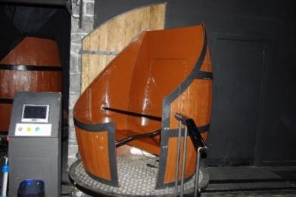  
Barrel Car on the Barrel Car ride

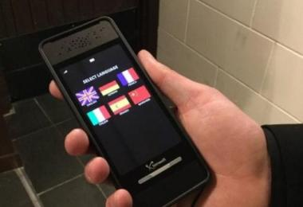  
Handset information available in 8 languagues

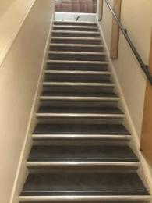  
staircase at exit of barrel car ride

#### The Sense of Scotland Room

* From the main entrance to this area, there is level access. Some display information is low, for wheelchair users. There are seats.
* There is a hearing loop.
* Some videos have subtitles.
* The Sense of Scotland Room has a 180 degree screen which has an audio-visual presentation. Customers are seated throughout the presentation on wooden benches. There is space for two wheelchairs within this area. The language devices can also be used here. Visitors are given a postcard with a map of Scotland and the whisky producing regions are highlighted by a 'scratch and sniff' mechanism. High contrast colours have been used and thick lines have been used to enable those with a sight impairment to be able to distinguish between the regions.

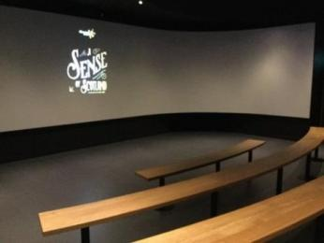  
Seating area in Sense of Scotland room

#### The Blender's Sample Room

* From the main entrance to this area, there is level access. Some display information is low, for wheelchair users. There are seats.
* There is a hearing loop.
* Videos have subtitles.
* The Blender's Sample Room is the next area on the tour, which is accessed from The Sense of Scotland Room via a widened doorway (950 mm wide). There is space for two wheelchairs in this room. There is a film and the tour guide also wears a microphone. The language devices can also be used here. The room is dimly lit. Coloured spot lighting is used to project onto the bench in front of you.

  
Interior of The Blender Sample room

#### The Diageo Claive Vidiz Scotch Whisky Collection

* From the main entrance to this area, there is level access. There is a hearing loop.
* The next area on the tour is accessed through a widened doorway from The Blender's Sample Room. The Diageo Claive Vidiz Scotch Whisky Collection is a room with floor to ceiling bottles of whisky lit by LED lights. This part of the tour is not seated, however a seat can be requested if required. A whisky tasting is conducted in this area. The language devices can be used here. The flooring in this area is marble.

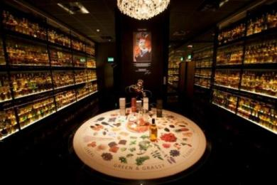  
The Diageo Claive Vidiz collection

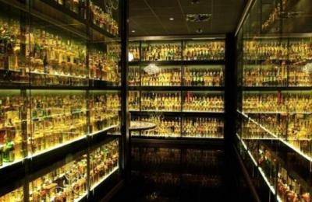  
Interior of the room with the Diageo Claive Vidiz colllection

#### The McIntyare Whisky Gallery and Bar

* From the main entrance to this area, there is level access. Some display information is low, for wheelchair users. There are seats.
* There is a hearing loop.
* The tour ends in the McIntyre Gallery and Bar. This is a large, brightly lit area with wooden flooring and seating. There are two steps up to a viewing gallery showing views to the south of Edinburgh. The rest of the area is flat. There is a lowered area at the bar. To exit the McIntyre Gallery there is a set of stairs down to a mezzanine level in the shop or the lift can be taken to the ground floor.

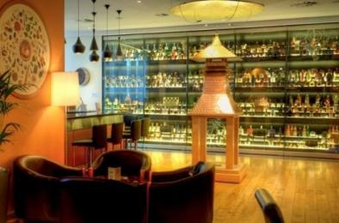  
The McIntyre Whisky Gallery and Bar

#### Public toilet

#### Unisex Accessible Toliet

* There is a public toilet for disabled visitors.
* From the main entrance to the public toilet, there is level access. The toilet door is 800mm wide.
* There is 780mm in front of the toilet. The toilet seat is 480mm high.
* There are horizontal grab rails located to the left of the toliet. There are baby changing facilities within this toliet. There is another public toliet on the first floor.

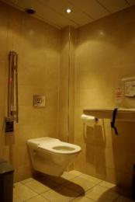  
Accessible Public Toliet

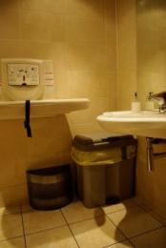  
Baby changing facilities within the Accessible Toliet

#### Shop

#### The Shop

* From the main entrance to the shop, there is level access. The door is 1200mm wide.
* The route through the shop is 800mm wide, or more.
* The flooring within the shop is a mixture of carpet and wood. There are two entrances to the shop. The main entrance is 1200 mm wide, while the side entrance is 840 mm. The shop is located over two floor, with a small mezzanine level only accessed by stairs. Our staff are available to assist customers who require merchanise from the mezzanine level. There is a low counter area and merchandise is displayed on shelves up to a height of 1880mm. Staff are available to help customers who require assistance to navigate between fixtures throughout the shop. There is low level background music playing as well as whisky-related noises which come from the wonder wall audio visual feature. A hearing loop system is available at all till points.

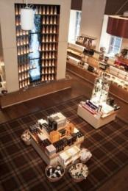  
Shop interior

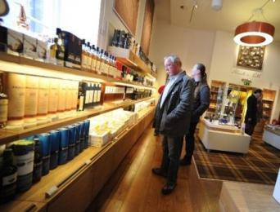  
Shop interior

#### Place to eat and drink

#### Amber Restaurant and Bar

* To get to a table, there are no steps.
* The menu is offered in large print.
* The route through the dining area is 800mm wide, or more.
* There is no background music.
* The table and plates have high colour contrast.
* We cater for sugar free (diabetic), vegetarian and gluten free (celiacs) specific diets.
* With advanced notice, all dietary requirements can be catered for. We also provide soya milk for coffee, tea and hot chocolate. The Amber Restaurant Whisky bar is adjacent to the main restaurant and serves over 400 whiskies. There are tables and chairs to sit on and bar seats. The nearest accessible toilet is located beside the main entrance to the restaurant.

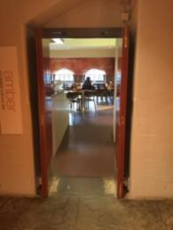  
Entrance to Amber Restaurant and Bar

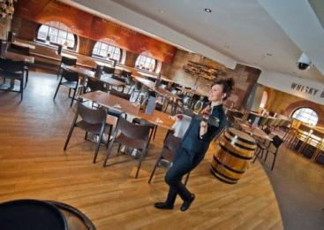  
Dining area in Amber Restaurant and Bar

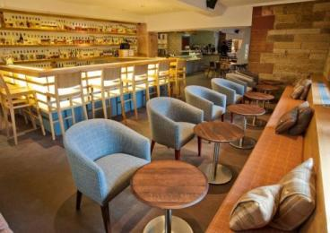  
The Amber Restaurant Whisky Bar seating area

## Customer care support

#### Accessibility equipment

* We have a hearing loop in all public areas throughout our attraction.
* We welcome assistance dogs and can provide water bowls for them. Please ask staff for assistance.
* The nearest toilet area for assistance dogs is located within Princes Street Gardens 20 metres from the main entrance.

#### Emergency evacuation procedures

* We have emergency evacuation procedures for disabled visitors.
* In the case of an evacuation, all customers inside the Attraction will be led to safety by a member of the team or by a member of the fire brigade.

#### Customer care support

* All staff have disability awareness training.
* Some staff have BSL training.
* We have information in audio, BSL, large print .
* We are translating our tour content into American sign language and this facility will be available from 1st August 2017.

Guide last updated: 29 May 2023